1. Implement a Document Collection Based on the Given Problem and Data Sets
For this assignment, a document collection was implemented in MongoDB using data from the Child Nutrition database.
The following JSON datasets were used:
- Module_Five_CTGNME.json – Food Category Name
- Module_Five_FDES.json – Food Description
- Module_Five_GPCNME.json – GPC Category Name
- Module_Five_WGHT.json – Weights
Each file was imported into the childnutrition MongoDB database as its own collection.
The following collections were created:
- ctgnme
- fdes
- gpcnme
- wght
These collections represent the Child Nutrition data in document format and support querying through MongoDB.
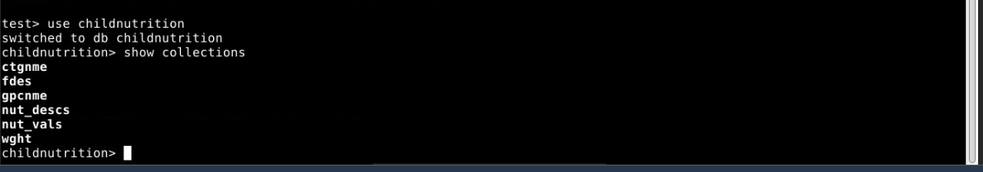
2. Perform Extract, Transform, and Load (ETL) Processes on the Data Sets
The ETL process was completed using MongoDB’s mongoimport command in Codio.
Extract: The data was extracted from the provided JSON files located in the Assignment Resources folder.
Transform: The JSON files were reviewed and prepared for import into MongoDB. Because the files were already in JSON format, minimal transformation was needed before loading.
Load: Each dataset was loaded into MongoDB using mongoimport.
command used:
mongoimport --db childnutrition --collection wght --file Module_Five_WGHT.json
This process was repeated for all four JSON files.
After import, all collections were successfully stored in the childnutrition database.
3. Execute the Provided Sentinel Queries to Verify Integration Success
The provided sentinel queries were executed in MongoDB to verify that the imported data could be queried successfully.
The following queries were run:
db.wght.countDocuments({ "row.Measure description": {$ne: null} })
db.wght.countDocuments({ "row.Measure description": {$eq: null} })
db.wght.countDocuments({})
db.wght.countDocuments({ "row.Measure description": {$eq: "cup"} })
These queries returned document counts successfully and confirmed that the imported wght collection was available and queryable in MongoDB.
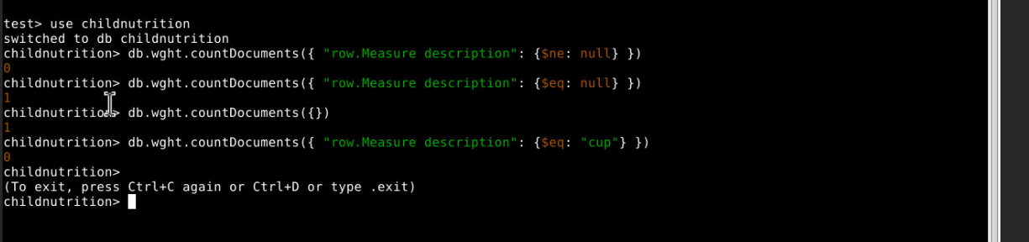
4. Explain How Each Query Validates Your Document Collection
Query 1: db.wght.countDocuments({ "row.Measure description": {$ne: null} })
This query checks how many records contain a value for "Measure description". It confirms the field exists in the collection and can be accessed through MongoDB.
Query 2: db.wght.countDocuments({ "row.Measure description": {$eq: null} })
This query checks for records where "Measure description" is null or missing. It helps verify completeness of the imported data.
Query 3: db.wght.countDocuments({})
This query returns the total number of documents in the wght collection. It confirms that the collection exists and contains imported data.
Query 4: db.wght.countDocuments({ "row.Measure description": {$eq: "cup"} })
This query searches specifically for records where "Measure description" equals "cup". It validates that nested fields within the document structure can be searched using Mongo Query Language..
5. Create a Backup of Your Instantiated Database Using the mongodump Tool
A backup of the childnutrition MongoDB database was created using the mongodump command.
The command used was: mongodump --db childnutrition --out ~/module5_backup
The backup was created successfully and generated BSON data files and metadata JSON files for each collection in the database.
This backup was then uploaded to my private GitHub repository titled: module5-2-Joshi
GitHub repository Screenshot

